# Online Course Reservation System

*SEQUENCE DIAGRAM*

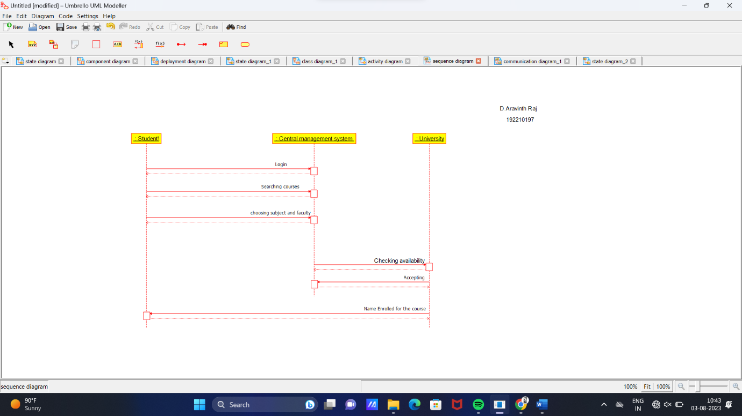

*COMPONENT DIAGRAM*

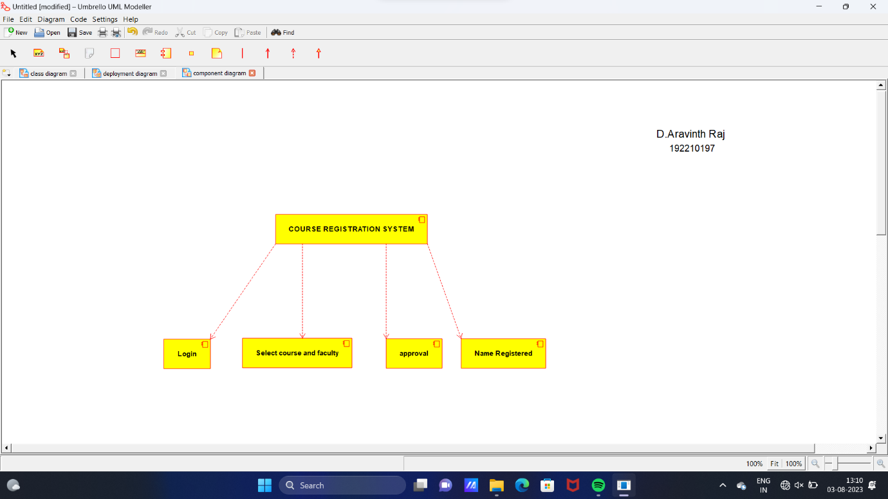

*DEPLOYMENT DIAGRAM*

